System Description

Motor Controller MCU Firmware

Viraj Ariyawangsha December 21, 2024



|  |  |
| --- | --- |
| Microcontroller | STM32F103C8T6 (STM Blue pill) |
| Platform | STM32 Cube IDE 1.13.1 |
| Programming Language | C |
| Link to source code | [*https://github.com/AryansVj/motor-controller*](https://github.com/AryansVj/motor-controller) |

# Firmware Architecture

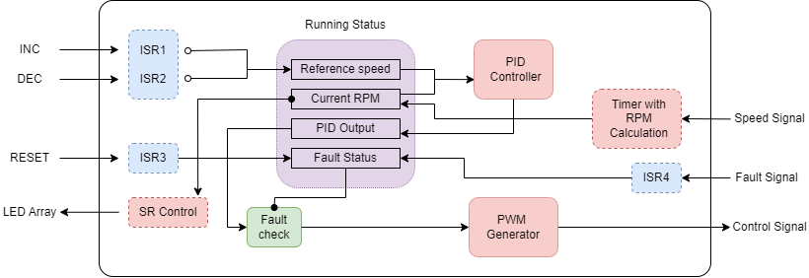

# Main components

***Running Status* struct:** A data structure defined to hold the real time parameters of the system providing a single point of access for write and read.

* **Reference Speed:** The speed required by the user – updated by user input (INC/DEC)
* **Current RPM:** The current rpm calculated by the Timer using motor controller feedback
* **PID Output:** The output generated by the closed loop PID controller output
* **Fault Status:** The True (1) / False (0) flag defined to indicate any fault conditions in the motor

**Timer with RPM Calculator:** A timer set to overflow at a sampling period of 600 ms (equivalent to 10 pulses at 100 RPM) with input capture configured to count the number of pulses that resets each time the timer interrupt is triggered. The count of pulses is used to calculate the current RPM and update in the *Running status* struct.

**PID Controller:** A closed loop PID controller that uses the reference speed, feedback motor speed and the tuned $K_{p}, K_{i} and K_{d}$ values to reduce the error.

$$error \left[i\right]=reference speed \left[i\right]-current RPM \left[i-1\right]$$

$$PID Output=\left[PID Controller gains\right]←error$$

**PWM Generator:** Another timer is used to generate the PWM signal of 100 Hz frequency by varying the duty cycle according to the PID output. In case of a fault condition, the PID output is bypassed and the control signal is set to stop the motor.

**SR Control:** Shift Register control logic to control the LED Array. Two cascaded shift registers of 8 outputs each is configured to switch on required number of LEDs according to the current RPM out of the 10 LEDs by setting their register value High.

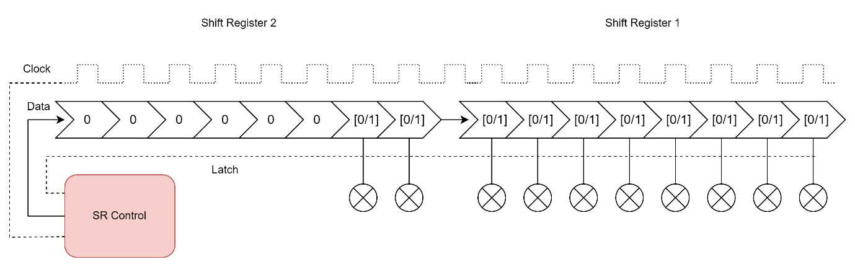

## Ports and Signals

|  |  |  |
| --- | --- | --- |
| Name | Function | Operation description |
| INC | A button to increase the motor speed | Trigger the ISR 1 to increase the reference speed by 100 RPM via interrupts |
| DEC | A button to decrease the motor speed | Trigger the ISR 2 to reduce the reference speed by 100 RPM via interrupts |
| RESET | A reset button to reset the fault status | Trigger the ISR 3 to set the fault status of the system back to false (0) |
| Fault Signal | Indication of a motor fault | Triggers the ISR 4 setting the fault status to true (1) |
| Speed Signal | Feedback from the motor control with running speed | A pulse train that corresponds to the current motor speed |
| Control Signal | PWM signal to control the motor speed | PWM signal governed by the PID controller is sent with the required duty cycle to set the motor speed |
| LED Array | A linear indicator of the current motor speed | A shift register is driven using the 3 GPIO to switch on the required number of LEDs out of 10 LED array |

# Operation Logic

Following is the flow of the system.

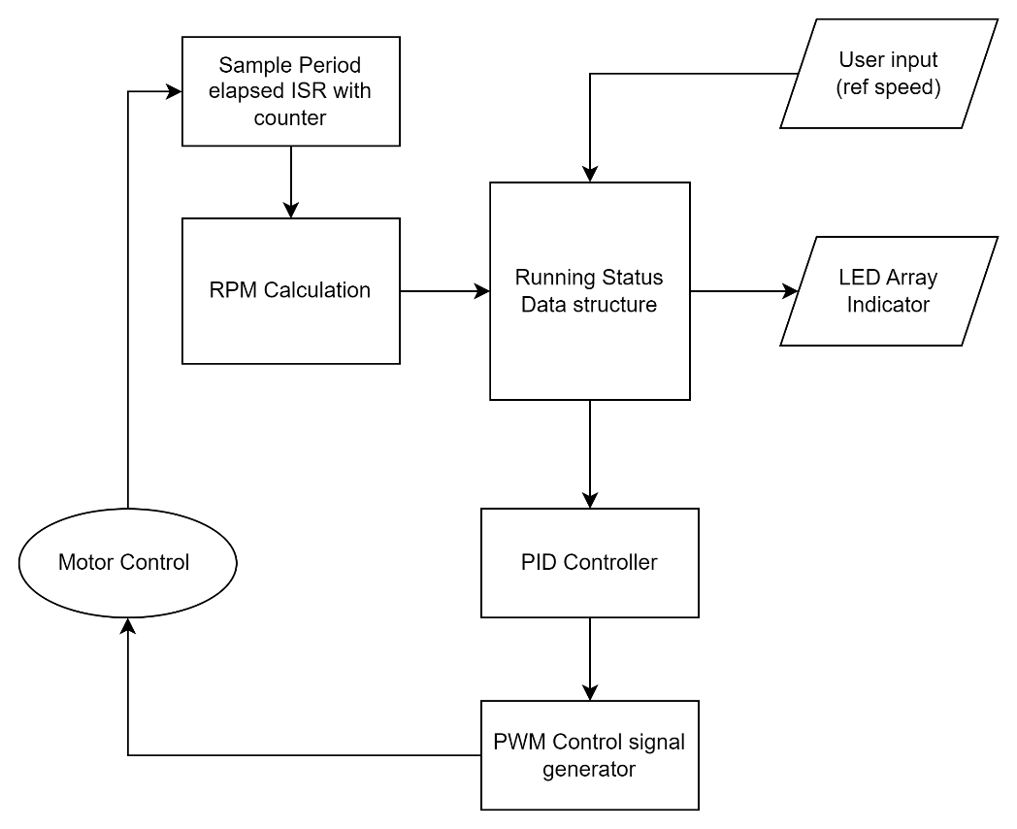

# Resource Allocation

|  |  |  |
| --- | --- | --- |
| Resource | | Function |
| TIM2 | General Purpose timer | Speed signal count capture and RPM calculation |
| PA0 | GPIO (in) |
| TIM3 | General Purpose timer | PWM Signal generation |
| PA6 | GPIO (out) |
| PA1 | GPIO_EXTI1 | External interrupt for INC button |
| PA2 | GPIO_EXTI2 | External interrupt for DEC button |
| PA3 | GPIO_EXTI3 | External interrupt for RESET button |
| PA4 | GPIO_EXTI4 | External interrupt for FAULT CONDITION signal |
| PA10 | GPIO (out) | LED Shift register data pin (DS) |
| PA11 | GPIO (out) | LED Shift register clock pin (SHCP) |
| PA12 | GPIO (out) | LED Shift register latch pin (STCP) |
| PC13 | GPIO (out) | Built in LED for testing |

# References

1. PID Controller library for ARM Cortex M (STM32) by Majid Derhambakhsh (<https://github.com/Majid-Derhambakhsh/PID-Library>)
2. STM32F103C8 Datasheet (<https://www.st.com/resource/en/datasheet/stm32f103c8.pdf>)